https://leetcode.com/problems/power-of-two/submissions/2191401775/

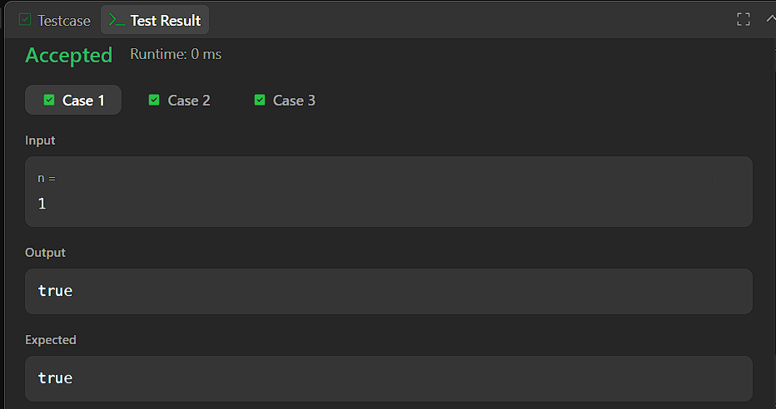

CODE:

bool isPowerOfTwo(int n) {
return n > 0 && (n & (n - 1)) == 0;
}

